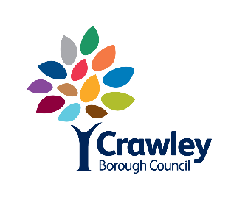

Facilities Services
Town Hall, The Boulevard
Crawley, RH10 1UZ

Tel: Crawley (01293) 438362

APPLICATION FOR INSCRIPTION IN THE BOOK OF REMEMBRANCE

Name and address

of Applicant

Date for entry in Book of Remembrance

MEMORIAL INSCRIPTION  For engravement layout purposes it is necessary for inscriptions to occupy TWO or FIVE lines | Name  Max. 39 letters  2nd line  Max. 39 letters  3rd line  Max. 39 letters  4th line  Max. 39 letters  5th line  Max. 39 letters
Date |  | Signature

- A price list is attached
- If a crest of insignia is to be incorporated in the inscription, the inscription must occupy five or eight lines, a diagram should be attached to the application
- The Council will arrange for inscriptions to be engraved in the Book of Remembrance on a quarterly basis
- Payment can be made using a debit or credit card, please note the council no longer accepts cheques

