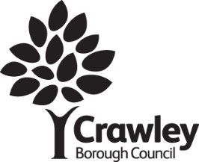
Data protection third party consent form.
For tenants of Crawley Borough Council
About this form
Use this form to give us permission to discuss your rent account / housing benefit claim / other information personal to your tenancy with another person.
This form is your consent to disclose information that is protected under the provisions of the Data Protection Act 2018.
Your details
Your full name
Your full address
Post code
Daytime telephone number
Email address

What information are you happy to discuss with the person named below? (Please tick all that apply)
- My rent account
- My housing benefit claim
- Other information that is personal to my tenancy (e.g. who lives with me)
Details of the person you would like us to discuss your information with
I give my permission for you to discuss my personal information with:
Their full name:
Their full address:
Post code:
Daytime telephone number:
Email address:
Their date of birth
Their relationship to you is (e.g. mother, friend, partner)

I understand that I may withdraw this consent in writing at any time.

Signed:............................................. . Date:............................
When you have signed and dated this form send it to:
The Housing Management Team
Town Hall, The Boulevard
Crawley
RH10 1UZ

